SVMC detail design

DOC. No.: | REV.: 00 |  |  | PRODUCT:
TITLE: SVMC detail design |  |  |  | Project:
Prepared by: | Donald huang |  |  | Date: | 11/8/2026
Remark: | Approval:
Remark: |  | Department | Title |  |  | Signature
Remark: | 1 | Electronic R&D
Remark: | 2 | QA
Remark: | 3 | GM

Revision | Description of Change | Author | Date
00

1. Overview 3
1.1. Reference 3
2. Bus connection plan 4
3. Software/Hardware version strategy 5
3.1. Hardware configuration 5
3.2. Software configuration 6
3.3. Component initialization 6
3.4. Sub boards 6
4. SVMC states 7
4.1. Diagnosis and checking 7
5. Test functions 9
6. Gate status 9
7. Code structure and code reuse 10
8. Multi-language support 11
9. Rinsing implementation 11
9.1. Rinsing 11
9.2. Purification 12

Overview

This document is to describe some major design issues of SVMC, including the system architecture, software structure, machine states, etc.

SVMC software improvement.doc is previous document about SVMC design. This document is the second version.

Reference

SL15 SW HLD.doc
Software Update Detail Design.doc
FB200_analysis.doc
SVMC software improvement.doc
Cleaning requirement.doc
NSL1000_product_hydraulics_configrations_Rev07.vsd

Bus connection plan

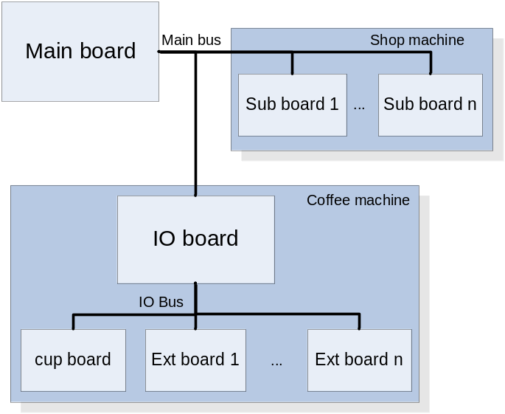

As the above figure shows, there are two types of machines with different connection plan.

For coffee machine (including cool beverage machine), main board only connect to the IO board through main bus, and the IO board control other sub boards through IO bus. This connection plan comes from the component/tree building software design (ref: FB200_analysis.doc). The component controller locates in the IO board. It has to use IO board as a center controller.

For shop machine, all boards are connected to the main board through main bus.

The following topics mainly discusses about the coffee machine, for shop machine is a concept.

Software/Hardware version strategy

For coffee machine, CIVET platform has 2 machine product lines to support: NSL1000 and SL15. Each machine product line has series of machine: BTC, ES, FB, IN, etc.

The hardware solution for IO board is to make big board (75608) to fit most machines (NSL1000 and SL15 complex version), SL15 simplify version will cut into small boards.

Software version strategy is to make one big program for each board. The program fits for all supported ME configurations. E.g. the program supports ES brewer, ceramic calve, and cooling unit etc. at the same time. A software configuration will apply to it when system boot to determine which components should work for the given ME configuration.

For this software strategy, merit is to have less version of software; demerit is the application doesn’t know the configuration at boot; it must wait for the configuration. That request IO board does nothing before the configuration being applied. To achieve this, the hardware design must implement two points:
- When IO board boot, all IO should go to the state make ME no action. Not heat the boiler, motor not run, etc.
- Soft reset and hard reset will take the same effect. This could achieve by add additional circuit to disconnect power to the MCU.

Hardware configuration

For a given board, all available IO will be defined in config.h/config.c, no mater they are used or not. IO board must receive a configuration before initialize components.

For example:

A PIB might have max 7 pumps.
In the config.h, there will be sth like:
enum{
PIB_PUMP1=13,
PIB_PUMP2=14,
…
PIB_PUMP7=25
}
For a ES NSL1000 maybe PUMP1,3,5,6 are available, others are disable

The configuration send by main board will have following information:
- component instant
- component options, e.g. gates available for each component.

struct
{
short componentId;
long options; // component configuration, could be gate or other option
}

The configuration can be retrieve from MDF connections.

Software configuration

Software configuration are:
- Product dependency
- Default adjustment
- User adjustment

Hardware and software configuration must be set before IO board initialization.

Component initialization

There are 3 steps for component initialization:
- init_xxx in main.c
- AbstractComponent_t.init_instance(int componentId,long options)
- AbstractComponent_t.diagnosis(int componentId)

2 & 3 perform after got configuration.

Note:
init_xxxs are to init the component class, register AbstractComponent_t, not the individual component with component id. They are run in main.c, not in the rtxc task. Do not call rtxc function: ks_xxx or comp_runner.c’s function like my_component. It should not move any moter or sensor.

After the configuration got, the system will call the init_instance one component by one component in a rtxc task. This function could startup heating (boiler,PIB), claim_output for common, etc.

After init_instance, diagnosis() functions should be called, component by component. Component should find home, check motor present, etc. in this function. report_str() should be called to infor UI for diagnosis status. If there is error, it should also call setCompErr().

Sub boards
To be continue…

SVMC states

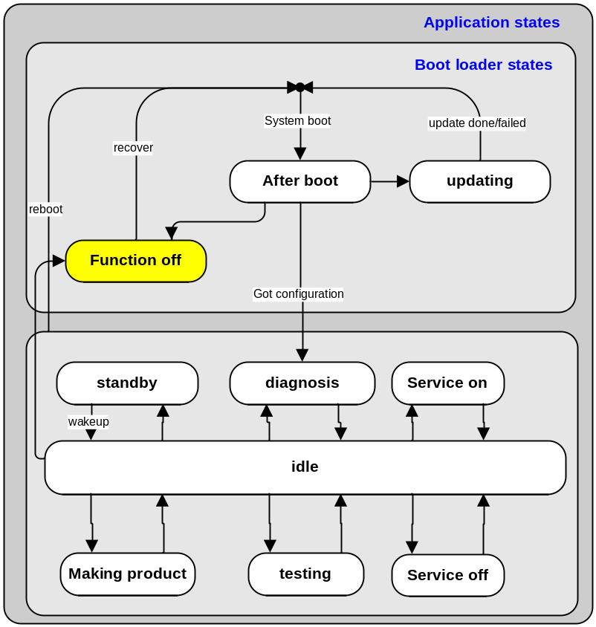

The above figure shows the IO board boot/application states.

There are some notes:
- Boot loader states are included in application states.
- When update fails, it reboot again, and go to boot mode, main board check for IO software state and know it is failed.
- In after boot mode, all IO should go to the state make ME no action. This should achieve by hardware, software should take no action.
- Function off is a special state. When IO board receives function off command, it will go in to MCU sleep mode. In sleep mode, it will not respond to any bus request, all components will not work. When a special hardware “recover” command sends to the IO board, the hardware will switch the board on again.
- When got configuration, all components in the configuration component list will initialize and perform diagnosis one by one.
- After application boot and go to idle state, vendui will monitor the boiler temperature. There is no specific state for this on IO board.
- There is no error state, error are control by main board application. When error happens, an error/warning message will send to main board.

Diagnosis

There should be a user interface to diagnosis the whole machine and each component by simple UI.

Whole machine diagnosis should also run on “initializing” state.

The different between diagnosis and checking is
Diagnosis run component by component, there is a UI showing the diagnosis progress status.

Service off/on
Service-“on”

A button that the operator can push. Components then perform their “service on” function (if they have one). E.g. the brewers go into their special service-position for cleaning and dismounting purposes. .

Service-“off”

Counterpart of service-on (Components then perform their “service off” function). This event can be generated by a button or by closing the door (as in SL).

Test functions

Test functions has INT16 return code, GVMC will get this return code.

Normally, return 0 for failure, 1 for success.

Gate status

For MDF driven coffee machine, each component has several gates (see FB200_analysis.doc). Status of gates will determine the tree building result. MDF manipulated in main board. Hence the main board will request IO board for gate status when needed.
The get gate status’ purpose is to disable the unavailable product, or find better way to make product.

To determine gate status on IO board, usually check the motor present (e.g. canister gate), the IR sensor (e.g. cup present), etc. The gate status checking probably takes time and gate status seldom changes.

The strategy of get gate status of IO board is to get the previous status of the gate. When components work: initialization, make product, test, component checking and background thread running, each component stores the current gate status in cache. Main board will get the gate status in the cache at once.

Gate statuses are checked in entering vend idle mode of vendui and vend idle for every few minutes.

Code structure and code reuse

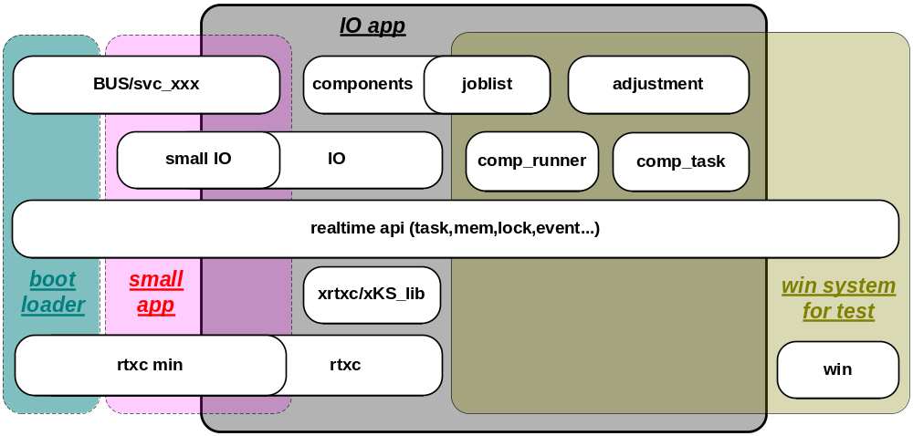

The above figure shows the SVMC software modules and code structure.

There are several types of program, as the big round rectangles shows:
- IO app.
- Small app. for small (sub)board
- Boot loader, for small and IO board
- Test program on Windows.

However, many of these modules are overlap. Modules in more than one program rectangle are reused.

Notes:
- The size of modules NOT implies the importance or complexity the modules are. It just for graphical space adjustment.
- Some specific modules, e.g. SVMC state management, software update, are not shown on the figure.
- Real-time api is placed in \trunk\public\realtime, is a abstract layer for both win32 and rtxc.
- xrtxc is mainly about task, it will be moved to realtime api
- xKS_lib is a wrapper of rtxc core objects
- Min rtxc contains simple tasks and static sema. Its size down to about 4k. Boot loader size is 16k/48k for small/IO board (see Software Update Detail Design.doc). It has enough space to use min rtxc in boot loader.

Multi-language support

Following strings need multi-language support for SVMC program:
- test names
- test/diagnosis report details

Solution:
- use string for language string index
- mix index and normal string
- use “@” pair to enclose
- “@” is not allow for other usage

Example:

@TEST_INDEX1@

@dosage@ = 10 g

These strings will be parsed by GVMC then lookup the lang.xml and translate to current languages.

Rinsing

According to the cleaning requirement, there are three major cleaning for NSL1000: rinsing, purification and de-clog.

For rinsing and purification, there are many flows. In XA SL1000 source code, a single multi-flow tree will be built for each process. However, this tree is very complicated.

There is another way to implement it which should be used in NSL1000 CIVET. That is treat one process as multi product. Each product has only one flow.

Rinsing
Mixer and brewer’s rinsing flush time is relatively short. Generate one tree for every component and make products one by one.

FB Brewer output gate connects to a mixer, the mixer motor will not run when FB brewer flushing. To flush FB Brewer, the connected mixer could be flushed at the same time. So the mixer which connected to FB Brewer should not be flushed individually.

To successfully make FB brewer + mixer tree, tree building must ignore mixer atLeastOneGate() attribute for the tree with FB Brewer component while filter candidate tree. This situation happens when rinsing or making normal product tree.

When rinsing tree building, because there is no ingredient for mixer & brewers, atLeastOneGate() attribute should be ignore anyway.

To control the rinsing product flow path for mixers and multi brewers, gate status of unwanted mixer & brewer should be set to false before build tree.

If component has malfunction, e.g. mixer motor not present, rinsing process should ignore the relative path, but other path should still need to be flushed.

When running rinsing, the boiler’s temperature should be legal when a rinsing product starts. Otherwise, the boiler should wait with timeout to boil water. Any product failure when rinsing will cause the whole rinsing process abort. And the ProductDone() will return non success.

Purification
Purification is soak brewer + rinsing.

To soak ES brewer, following steps will be taken:
- open the brewer head: by run a test function for brewer
- prompt user to place tablet, then press start button: by UI
- close brewer head, fill in 70cc water: by make a product with 70cc water
- wait 40 seconds: by UI
- Many steps to move head, cylinder, and flush water: by make 4 product similar to rinsing, but in execute_job_list() perform different. Each product has only 1 flow, with different dosage: 50cc, 50cc, 30cc, 50cc.

ES brewer test functions and product type summary:
- 1 test function for step 1
- 2 types products for step 3,5

To soak FB brewer, following step will be taken:
- open the brewer head: by run a test function for brewer
- prompt user to place tablet, then press start button: by UI
- close brewer head, fill in 140cc water: by make a product with 140cc water
- wait 45 seconds: by UI
- brewer chamber is blown empty: by a test function
- fill in 120cc water: by make a product same at step 3
- wait 45 seconds
- brewer chamber is blown empty: by a test function same as step 5
- fill in 50cc water: by make a product same at step 3
- wait 9 seconds
- brewer chamber is filled with another 150 cc then directly blown empty: by make a product.

FB brewer test functions and product type summary:
- 2 test function for step 1,5(8)
- 2 types products for step 3(6,9),11

Note:

Mixer not behind the FB brewer should be flushed in the waiting interval. Mixer behind the FB brewer should not be flushed.

For different machine configurations, there might be many cases 1xES, 2xES, 1xES+1xFB, 2xFB. The key for purification is tree building and multiple test function, product and wait time order management.

Declog
Make a declog product with 15cc water.

